C. V.
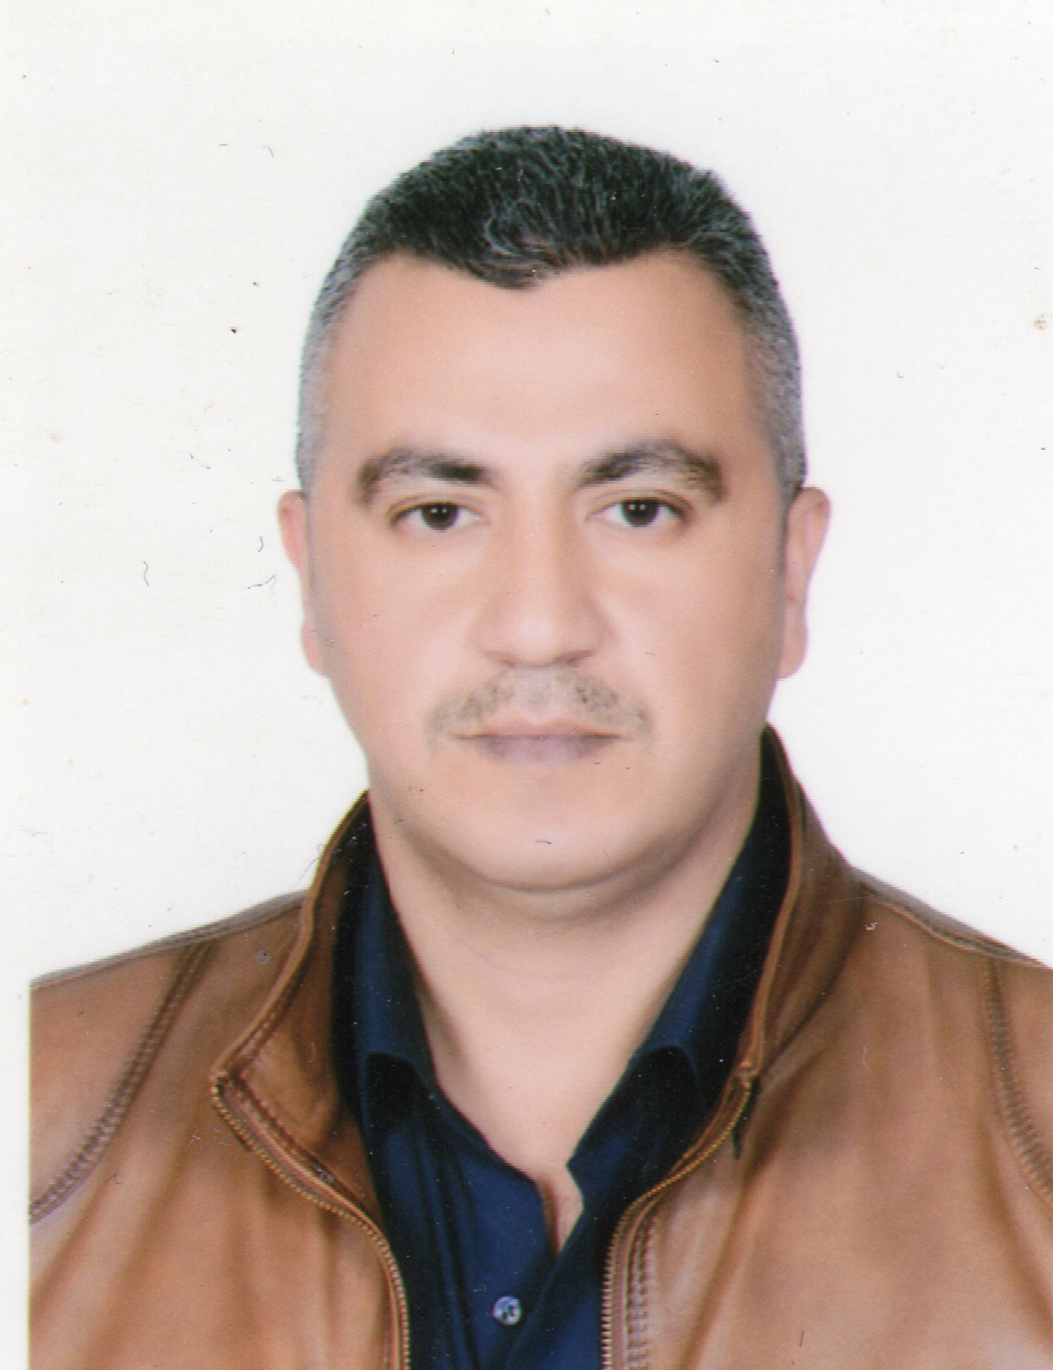

Personal Information

Full name: Ziad Naeser Karim
Nationality: Iraqi
Address: Iraq - Baghdad
Date of Birth: 1979/August/13
Phone No.: (07722300869) & (07500948819)
Email: (ziadn9166@gmail.com)

Education and Qualifications
- I have Graduate of Technical Institute for the year 2000

Skills & Abilities
- Able to manage the planning and implementation strategy in any project of humanitarian and non-humanitarian organization in accordance with its instructions and procedures effectively and practically.
- I have commitment to works and duties respectfully till the deadline either in leading or in collaboration with any specialist team work.
- I'm quick learner, successful, flexible, open-minded, and able to listen to others and reach out to them.
- I like the working with humanitarian organizations to help people, especially the refugees and returners, and I have knowledge about how to distribute aids or food.
- Able to work and live with multicultural teams.

Experiences:
- I have an experience in working on Computer field Windows application and Microsoft Office Word & Excel. Outlook. I have experience in photography and I have a permit
- I have an experience in working on the security filed and sites management.
- I have experience in logistics, transportation, storage and management.

Positions and Workplaces:

-I worked for Oxfam in Baghdad 2018. Office guard
-I worked Logistics Assistant NRC. Baghdad Office . Expiration of the contract
-I worked with organization NCR for three years as the in charge of its stores, from 01/12/2014 to 31/12/2017 Baghdad Office
-I worked in free businesses in 2013 – 2014. Completion of the project .
-I worked with American AL-Morel Company Storekeeper 2010-2012. Baghdad International Airport .
-I worked with American Bechtel Company Field Assistant in 2006 - 2007. Baghdad Power Station Expiration of the contract. Completion of the project
-I worked with Siemens International Logistics Assistants/Storekeeper in 2004 - 2006Baghdad Power Station. Completion of the project .

Courses and Training Participations:

A course in combating administrative and financial corruption . Organization Oxfam-

-Holding a training course from the Logistics Management Group in Warehouse Management and Transport Management 2017.
- I was awarded a Training Certificate from the Kaya in the field of Anti-Corruption.
-I received a certificate of appreciation from the United Nations in field security

Languages:
Speaking: Arabic:
Fluent Reading: Fluent Writing: Fluent

English:

Speaking: Average Reading: Good Writing: Good

